BreadTalk Training Manual

 |  | Donuts–Rainbow – Trang trí
Product Specifications/ Quy cách
Chiều dài: - |  |  | Stacking: No
Hình dáng: Tròn |  |  | Chiều rộng: 11cm
Màu sắc: - |  |  | Chiều dài: 4cm
Ingredients/ Thành phần
1. | Dark Chocolate Compound/ Hợp chất sô-cô-la đen |  | -15g
2. | Rainbow Chocolate Bits |  | -2g
Operating Tools/ Công cụ
1.Parchment Paper/ Giấy thấm dầu |  |  | 2. Weighing Scale/ Cân
Preparation Procedures/ Chuẩn bị
Nhúng 1 mặt của donut vào sô-cô-la (30g) |  |  | Một mặt donut nên được phủ sô-cô-la như hình. |  | Rắc rainbow chocolate bits (3g) trên mặt phủ sô-cô-la.
Sản phẩm hoàn thành.
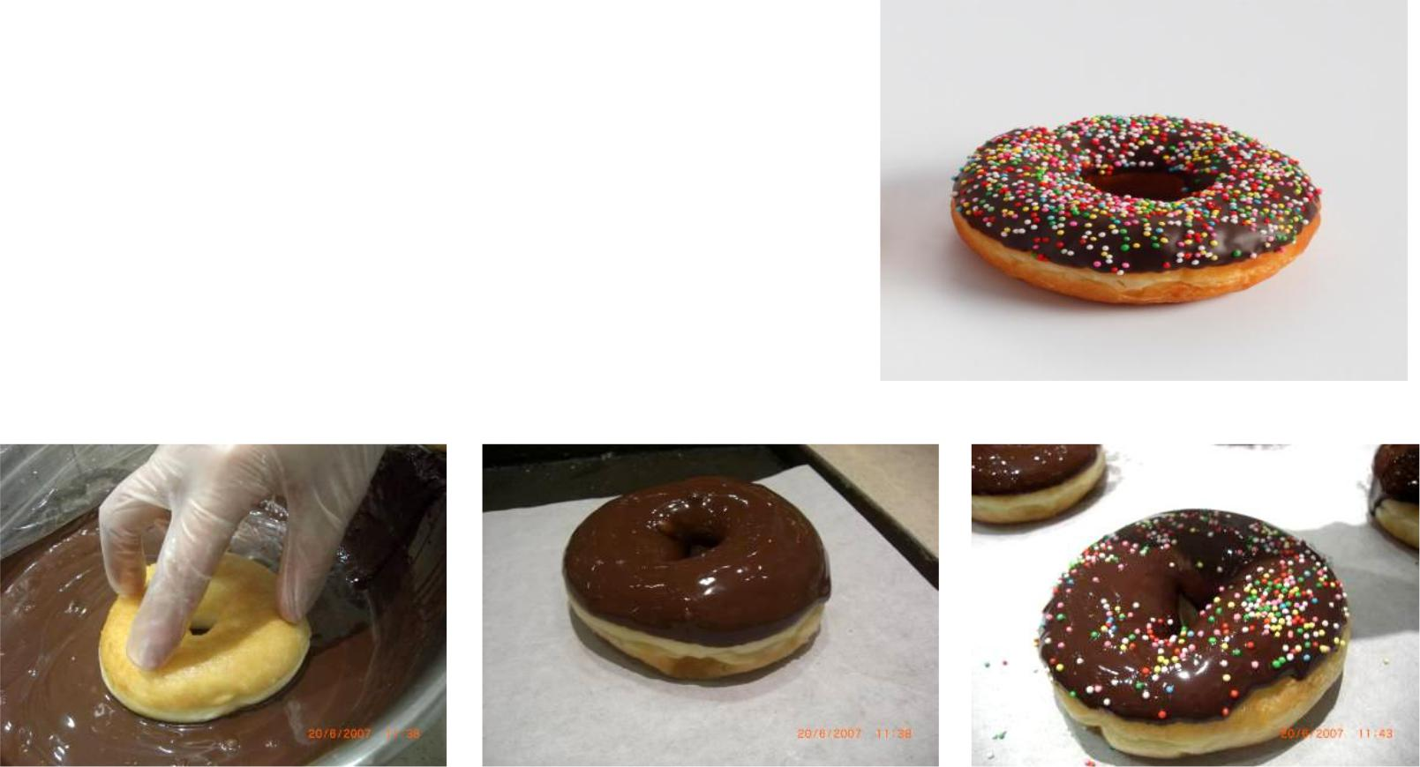

BreadTalk Training Manual

Donuts–Rainbow - Assembly
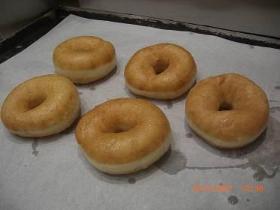

Ingredients
1. | Sweet Bun Dough |  | -30gm
Operating Tools
1. | Rolling Pin | 2. | Weighing Scale
3. | Scraper | 4. | Grey Tub
5. | Baking Tray

Preparation Procedures

Cut dough into portions of 1800gm | Press the dough evenly on top of | Line the dough in a grey tub, 8x5.
each. Rest the dough in a grey tub | the plate. Calibrate the dough | Allow dough to rest for 15min-
for 10min. | divider to 50gm. Place the plate | 20min.
 | of dough under the machine and
 | activate it. Yield: 36 dough
Shape the dough to make slightly | Flatten the dough using rolling pin | Flip the dough. Start to fold from
oval with a length of 5cm with a | into a longitudinal shape of 12cm | one length to the other.
width of 4cm. | long with a width of 5cm.
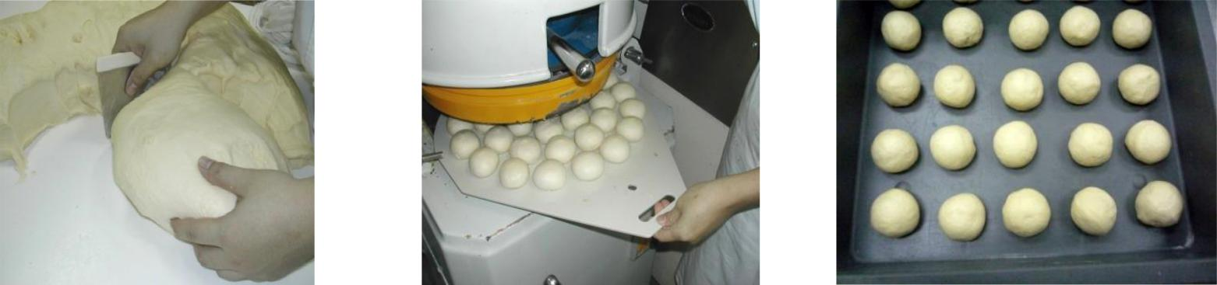
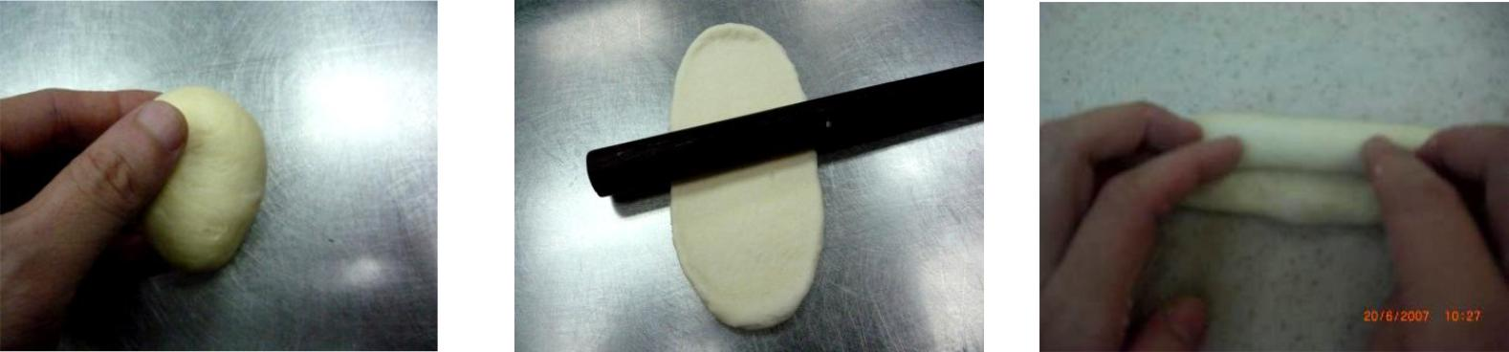
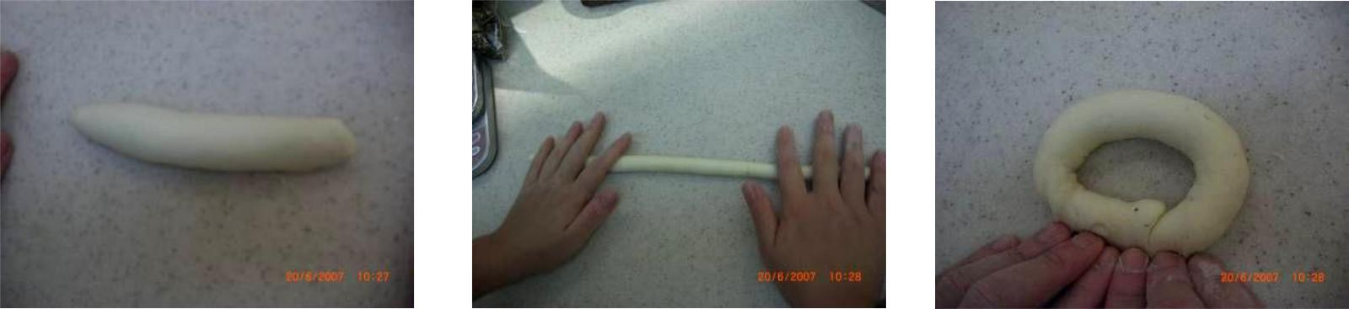
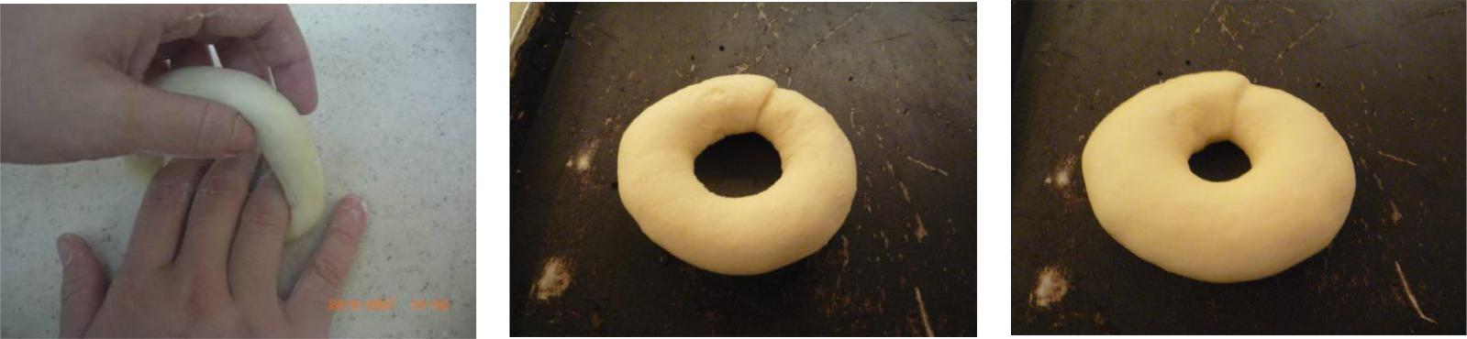
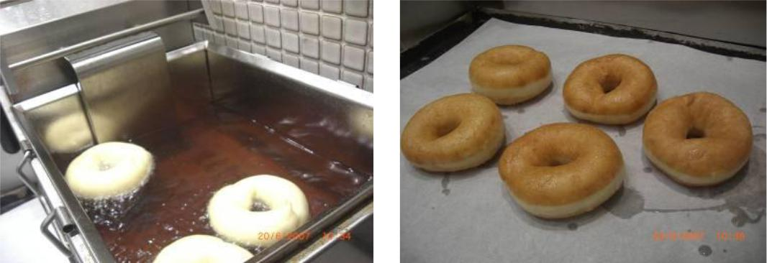
BreadTalk Training ManualThe dough should be a stick that isLengthen the dough to 26cm long.Join both ends together.12cm long and 2cm wide.Ensure that the ends are securelyPlace 12 dough on the baking trayAllow the dough to rest for 10min-joined. The dough should be 10cmand send to proof.15min after removing from thein diameter.Grams & Salva FC46:proofer.Temperature: 32°CHumidity: 80%Time: 40min-45minSize of bun should be twice itsoriginal size after proofing.Deep-fry the dough in oil of 180°C.Place the donuts on parchmentEach side should take around 3minpaper to drain away the excessto turn golden brown.oil.

